**Artificial Intelligence Lab**

**LAB 1 – Implementation of toy problems**

**Aditya Kumar**

**RA1911030010100**

**O2 Section**

**Date – 4/1/22**

**Problem Statement:**

A person has 3000 bananas and a camel. The person wants to transport the maximum number of bananas to a destination which is 1000 KMs away, using only the camel as a mode of transportation. The camel cannot carry more than 1000 bananas at a time and eats a banana every km it travels. What is the maximum number of bananas that can be transferred to the destination using only camel (no other mode of transportation is allowed).

**Algorithm:**

1. Get distance and number of bananas as input
2. Divide the distance into three points
3. Calculate the trips needed to carry bananas from one point to another
4. Calculate the number of bananas left after travelling between all three points
5. Add all the bananas

**CODE:**

import math

dist=int(input("Enter the distance: "))

banana=int(input("Enter the number of bananas: "))

ip1=banana-dist

trip1=(2*(ip1/dist))+1

ip2=banana-ip1

trip2=(2*(ip2/dist))+1

x=math.ceil((banana-ip1)/trip1)

y=math.ceil((ip1-ip2)/trip2)

z=math.ceil(dist-x-y)

left=ip2-z

print(str(left) + " is the number of bananas remaining")

**INPUT:**



**OUTPUT:**

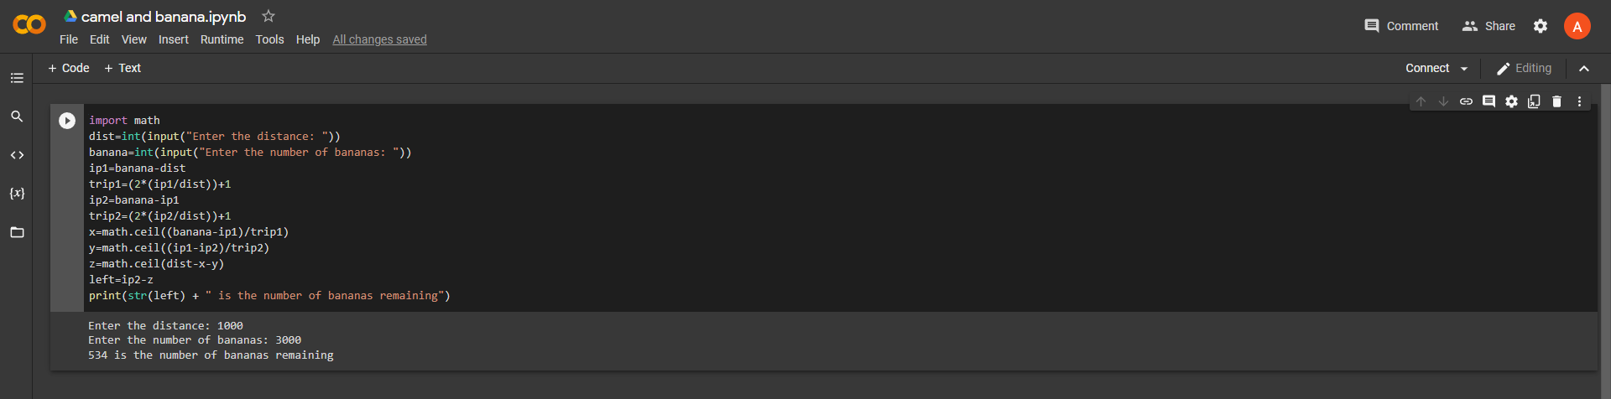

**RESULT:**

Hence the toy problem was executed and desired output was obtained.